MATHEMATICS METHODS

MAWA Semester 1 (Unit 3) Examination 2019
Calculator-free

Marking Key

© MAWA, 2019
Licence Agreement
This examination is Copyright but may be freely used within the school that purchases this licence.
- The items that are contained in this examination are to be used solely in the school for which they are purchased.
- They are not to be shared in any manner with a school which has not purchased their own licence.
- The items and the solutions/marking keys are to be kept confidentially and not copied or made available to anyone who is not a teacher at the school. Teachers may give feedback to students in the form of showing them how the work is marked but students are not to retain a copy of the paper or marking guide until the agreed release date stipulated in the purchasing agreement/licence.

The release date for this exam and marking scheme is 14th June.

Section One: Calculator-free (50 Marks)

Question 1(a) (2 marks)
Solution
Mathematical behaviours | Mark
- applies product rule  - differentiates exponential correctly | 1  1

Question 1(b) (3 marks)
Solution
Mathematical behaviours | Marks
- applies quotient rule  - differentiates correctly  - simplifies result | 1  1  1

Question 1(c) (3 marks)
Solution
Mathematical behaviours | Marks
- states  - states  - states in terms of | 1  1  1

Question 1(d) (3 marks)
Solution
Mathematical behaviours | Marks
- differentiates to obtain  - equates  - determines value | 1  1  1
Question 2 (a) (4 marks)
Solution
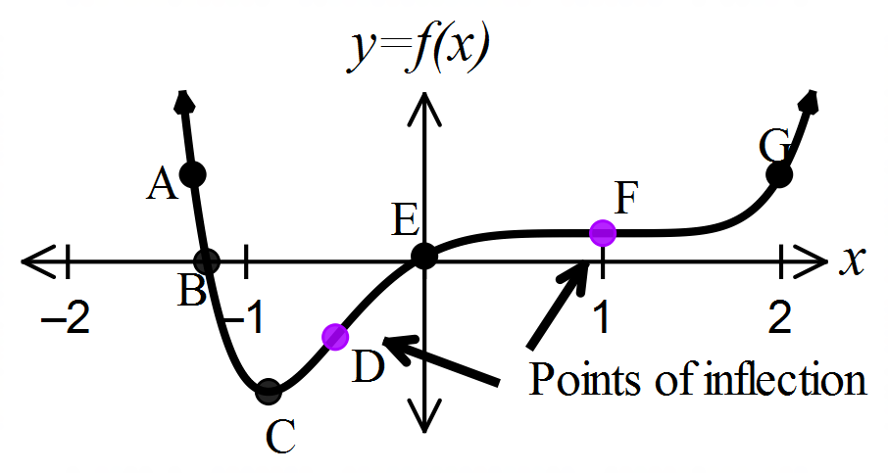(i)

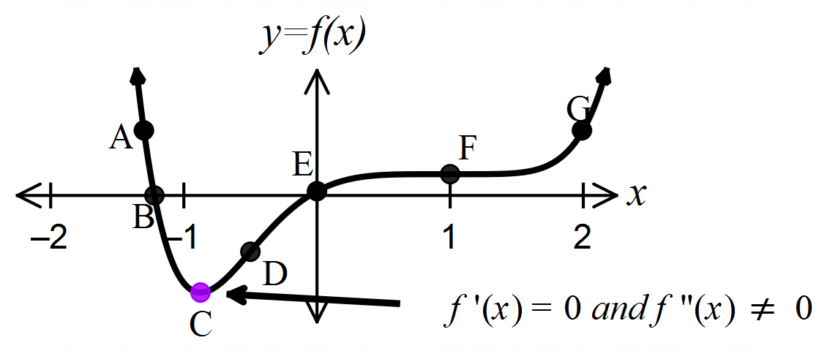
(ii)

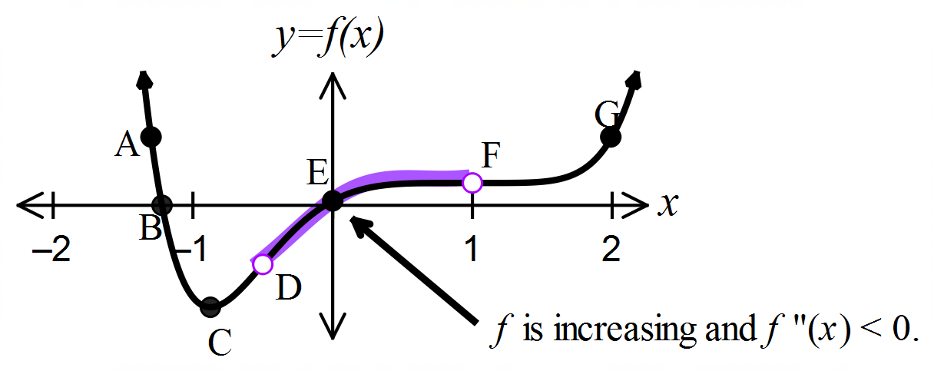

(iii)

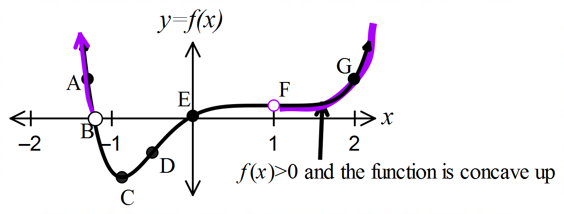
(iv)

Mathematical behaviours | Mark
(i)  - states D and F  (ii)  - states C  (iii)  - states E  (iv)  - states A and G | 1  1  1  1

Question 2(b) (1 mark)
Solution
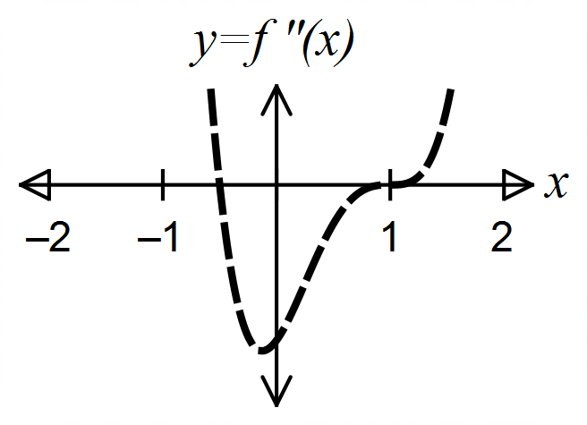

Mathematical behaviours | Marks
- circles the 2nd graph | 1
Question 3 (4 marks)
Solution
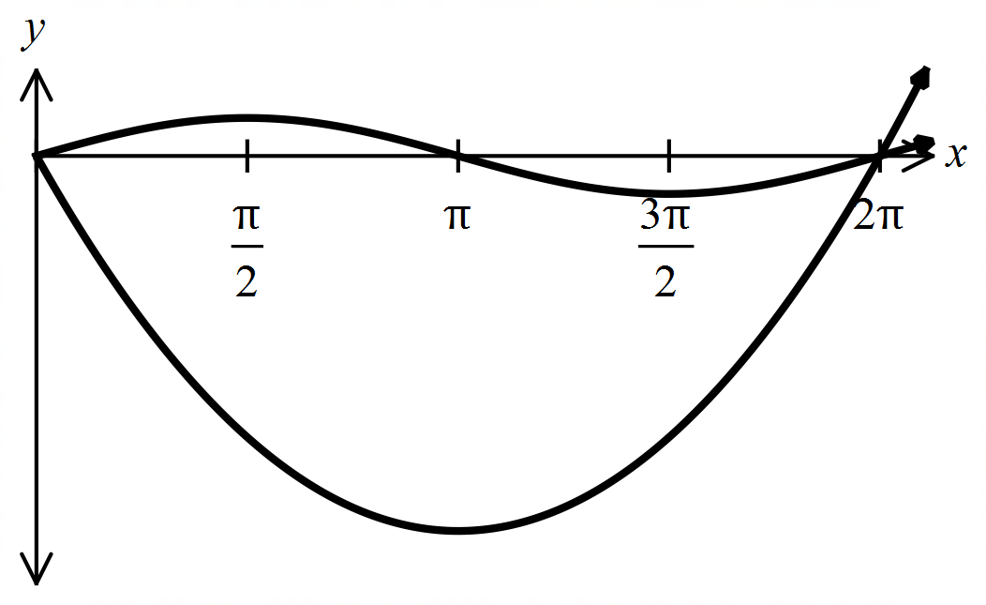 Area =
=
=
=
=
=
Mathematical behaviours | Marks
- states a correct expression using integrals to determine the area  - anti-differentiates each part correctly  - substitutes in limits of integration  - evaluates result | 1  1  1  1

Question 4(a) (2 marks)
Solution
Mathematical behaviours | Marks
- anti-differentiates the exponential function correctly  - anti-differentiates the square root function correctly | 1  1

Question 4(b) (2 marks)
Solution
Mathematical behaviours | Marks
- aniti-differentiates correctly  - substitutes limits of integration and evaluates | 1  1

Question 4(c) (2 marks)
Solution
=
Mathematical behaviours | Marks
- uses the relationship =  - applies Fundamental Theorem of Calculus | 1  1

Solution
Mathematical behaviours | Marks
- anti-differentiates integral correctly  - substitutes in limits of integration correctly and simplifies to obtain correct  expression on the LHS  - determines correct answers for | 1  1  1
Question 4(d) (3 marks)

Question 5(a) (3 marks)
Solution
Bernoulli distribution with

Mathematical behaviours | Marks
- states Bernoulli  - states mean  - states variance | 1  1  1

Question 5(b) (3 marks)
Solution
This represents a Binomial with and
Mathematical behaviours | Marks
- states Binomial  - states  - states | 1  1  1

Question 5(c) (1 mark)
Solution
Mathematical behaviours | Marks
- states correct expression | 1

Question 5(d) (3 marks)
Solution
Mathematical behaviours | Marks
- recognises the situation involves a binomial and conditional  probability  - states correct expression for numerator  - states correct expression for denominator | 1  1  1

Question 6(a) (1 mark)
Solution
(i) Under-estimated Area =
=
(ii) Over-estimated Area =
=
=
Mathematical behaviours | Marks
(i)  - states the sum of the area of the two rectangles and simplifies correctly  (ii)  - states the sum of the area of the three rectangles and simplifies correctly | 1  1

Question 6(b) (2 marks)
Solution
Using trapeziums is equivalent to averaging the results from part (a)
i.e. Estimated area under from to is
=
=
=
Mathematical behaviours | Marks
- determines the average of the two areas obtained in part (a)  - simplifies to deduce the required result | 1  1

Question 7(a) (1 mark)
Solution
Mathematical behaviours | Mark
- States correct answer | 1

Question 7(b) (3 marks)
Solution
Mathematical behaviours | Marks
- integrates both sides of equation  - applies fundamental theorem  - rearranges to get required result | 1  1  1

Question 7(c) (3 marks)
Solution
Mathematical behaviours | Marks
- recognises term is to be involved  - states correct integral and bounds of integration  - substitutes bounds of integration and simplifies | 1  1  1

